WEEK 06 PRACTICE SESSION
ROLL NO:241801314
NAME:VIKASHINI.M
WEEK 06-01
Q1
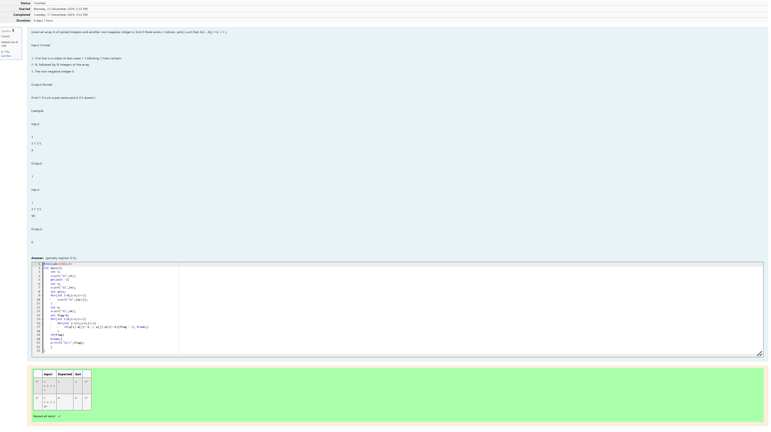
Q2
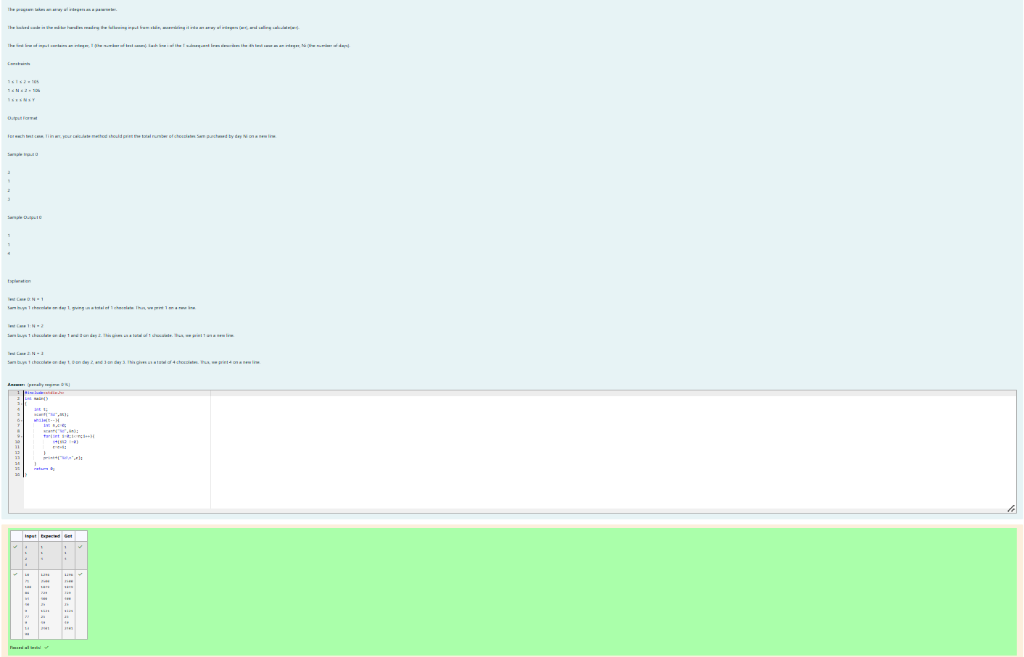
Q3
